Step One;

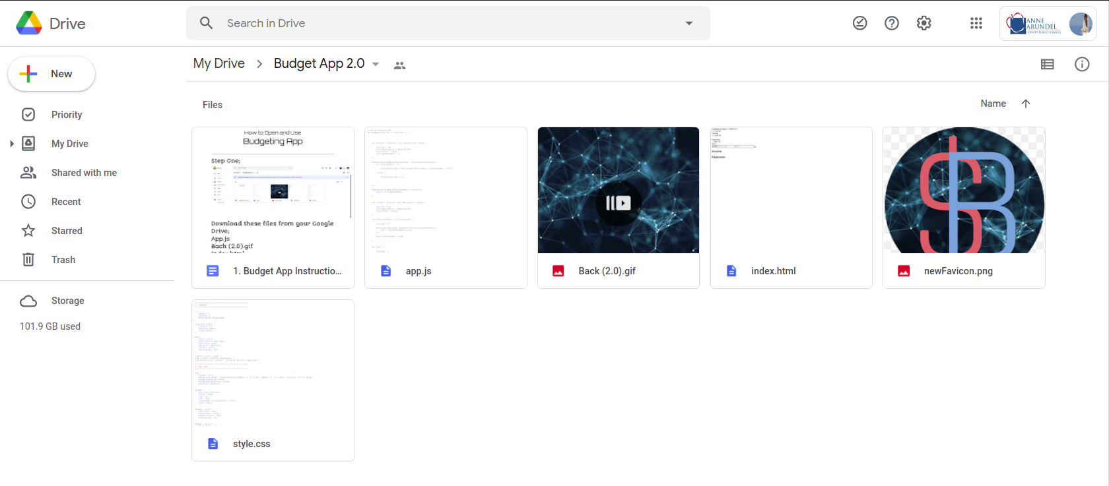

Download these files from your Google Drive;

**App.js**

**Back (2.0).gif**

**index.html**

**style.css**

**newFavicon.png**

(You can also just download the folder to get all of the files at once)

Step Two;

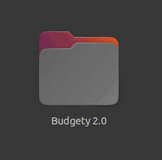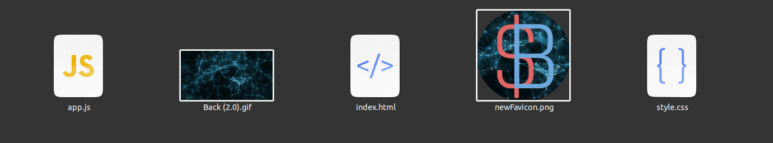

You should be able to go to your files to see the files/folder downloaded. **The next steps may be tricky, and may not be accessible to everyone.**

Step Three;



Right-click on this file (index.html) to open a side view tab. Go to “Open with...” and then click on the option to open with your web browser. It should automatically open up a new browser tab with the budget app/website ready for use!

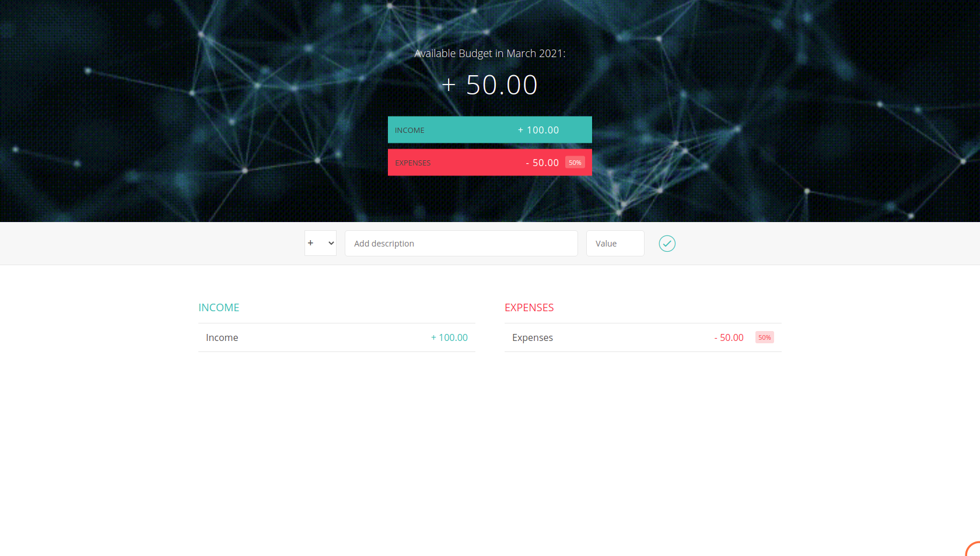

And there you have it! A Budgeting App created and coded by Vishnu Dev Padoli.